CURRICULUM VITAE OF ENGR. PROF. EMENIKE.C EJIOGU
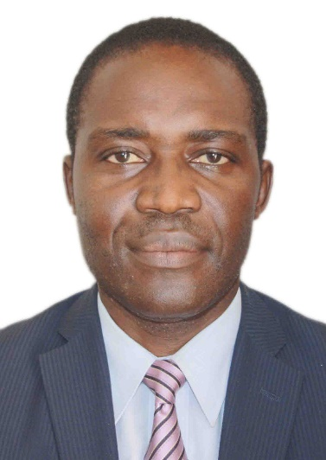

University of Nigeria, Nsukka


Prof. Emenike C. Ejiogu
- Bio-data/Contact
- Name: Ejiogu, Emenike Chinedozi
- Date & Place of Birth: 1966.04.06 (Lagos, Nigeria)
- Sex: Male
- Contacts: 090 9707 4888 (Japan); 081 2586 4681(Nigeria); emails: emenike.ejiogu@unn.edu.ng; eev25098@fc.ritsumei.ac.jp
- Education
- Bachelors Graduation: 1987.06 (Bachelor of Engineering, University of Nigeria)
- National Youths Service Corps (NYSC): 1987.09 – 1988.08 (Ogun State, Nigeria)
- Master of Engineering Studies: 1988.09 –1990.03 (Master of Engineering, University of Nigeria)
- Japanese Language Studies: 1990.04 – 1990.09 (Diploma in Japanese Language, Nagoya University, Japan)
- Post-Graduate Research & PhD Studies: 1990.10 – 1994.03 (Doctor of Philosophy, in Power Devices & Systems ), Shinshu University, Nagano-city, Japan)
- Professional Experience
- National Youth Service Corp(NYSC) Engineer, WAPCO Cement Factory, Ewekoro, Ogun State, Nigeria (1987.09 – 1988)
- Assistant Lecturer(Part time): Department of Electrical Engineering, University of Nigeria, Nsukka, Enugu State (1988.10 – 1990.03)
- Lecturer: Department of Electrical & Electronic Engineering, Ritsumeikan University, BKC, Kusatsu-city, Japan (1994.04 – 1997.03)
- Assistant Professor: Department of Electrical & Electronic Engineering, Ritsumeikan University, BKC, Kusatsu-city Japan (1997.09 – 2001.09)
- Associate Research Fellow: Department of Electrical & Electronic Engineering, Ritsumeikan University, BKC, Kusatsu-city Japan (2001.10 - Present)
- Chief Research Engineer, E-Tec Co. Ltd, Osaka, Japan (2001.10.- 2005.12)
- Director of Research, Energy & Environmental Technology Inc., Osaka, Japan (2005.12. – 2012)
- Director-General (DG), MicroSilitron Inc., Laboratory, Biwako Campus, Faculty of Science & Engineering, Ritsumeikan University, Kusatsu-city, Japan (2007.04 – 2009)
- Research Professor, ,Mirai Denchi Labaratory, High Tech Research Centre, Ritsumeikan University, ,Kustatsu-shi, Shiga-ken, Japan (2009.10 – Present)
- Professor, Department of Electrical Engineering, University of Nigeria, Nsukka, Enugu State (July 2011 – Present)
- Director, Laboratory of Industrial Electronics, Power Devices & New Energy Systems (LIEPNES), Department of Electrical Engineering, University of Nigeria, Nsukka (2011 – Present)
- Chairman, Faculty Research Grant and Research Linkage Committees, Faculty of Engineering, University of Nigeria, Nsukka (2012 – Present)
- Head of Department, Department of Electrical Engineering, University of Nigeria, Nsukka, Enugu (August 2013 – July 2016)

- Membership of Professional Societies
- Member, New York Academy of Sciences, New York, USA ( 1996 – Present)
- Member, Institute of Electrical and Electronic Engineers (IEEE), USA (1992 – Present)
- Member, Japan Institute of Electrical Engineers (IEEJ), Tokyo, Japan (1994 to Present)
- Member, European Power Electronics Association (EPE), (1997 – Present)
- Registered Engineer, Council for Regulation of Engineering in Nigeria (COREN), (2011 – Present)
- President, Nigeria in Diaspora Organization (NIDO), Japan (2008 – Present)
- Board member, Nigerian Chamber of Commerce & Industry, Tokyo, Japan (2011-Present)
- Current Areas of Research Interest & Product Development
- Conventional & Renewable Energy Devices & Systems
- Electrochemical & Electromechanical Energy Generation Devices & Systems
- Power Electronic Systems (Inverters and electric drives, UPS, Voltage ultra-stabilizers, energy-saving systems, etc)
- Parametric Oscillation Systems & Applications ( advanced sensors, power conversion & wireless power transfer, etc)
- Plasma generation and applications (environmental clean-up/remediation, medical devices applications, etc
- Bio-fuels & Applications (bio-diesel production , biomass gasifier systems, biomass stove, etc)
- Industrial Electronics and related engineering Applications in Agriculture & Food Processing
- Biometrics, Electronic Surveillance, Security & Alarm Systems ( face/iris/finger recognition systems, intruder detection, restricted area surveillance and protection, etc)
- Miscellaneous Engineering Devices & Systems (contract research)

- International Patents & Scientific Research Publications
Has over six (6) international patents/inventions in engineering and over 50 publications in peer reviewed international journals & conferences
- Languages : Igbo (Nigerian),Ogba (Nigerian), English, Japanese

- Hobby: Life itself

